Game Design Document

Fill up the following document

K.Premkiran Project no 45: 8-12-2021

1. Write the title of your project.

Dancing Robot

1. What is the goal of the game?

The goal of the game to make the robot and animals to dance according to the music

1. Write a brief story of your game.

The story of the dancing robot: the robot goes a dancing party with his close friends: Cats, Moose. Robot continuously dance with the music with his friends. Sometime with the cats, sometime with the moose.

1. Which are the playing characters of this game?

* Playing characters are the ones who respond to the user based on the input from the user.
* Cars, monkeys, dinos, wizards, etc., are the playing characters in the game.

|  |  |  |
| --- | --- | --- |
| Number | Character Name | What can this character do? |
| 1 | Robot dancer | Main dancer |
| 2 | Cats – co-dancers | co-dancer |
| 3 | Moose – co-dancers | co-dancer |
| 4 |  |  |
| 5 |  |  |
| 6 |  |  |
| 7 |  |  |
| 8 |  |  |

1. Which are the Non-Playing Characters of this game?

* Non-Playing characters are the ones that don't have an action or behavior when the user interacts with the game.
* Hurdles, stones, bananas, coins, etc., are non-playing characters in the game.

|  |  |  |
| --- | --- | --- |
| Number | Character Name | What can this character do? |
| 1 | Changing colors | Changing colors |
| 2 | Changing shapes of the object | Changing shapes of the object |
| 3 |  |  |
| 4 |  |  |
| 5 |  |  |
| 6 |  |  |
| 7 |  |  |
| 8 |  |  |

Draw your imagination of this game. What does this game look like?

* Draw the game either on your computer or on paper.
* Add images of the game scenes to show each of the playing and non-playing characters at least once.

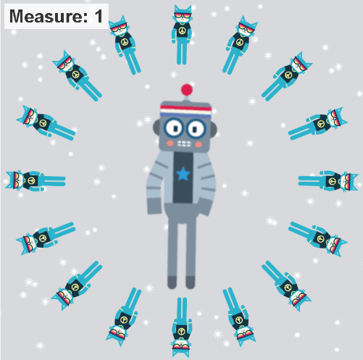

How do you plan to make your game engaging?

1. The background, co-dancers will be changed alternatively.
2. The background colors will be changed according to the music.